UNIVERSITY OF ZIMBABWE
FACULTY OF COMPUTER ENGINEERING, INFORMATICS AND COMMUNICATIONS
DEPARTMENT OF COMPUTER SCIENCE
TITLE: DESIGN AND IMPLEMENTATION OF A SMART TRAFFIC LIGHT CONTROL SYSTEM FOR MULTI GRID NETWORKS
NAME OF STUDENT: MAKANAKA MATSIKA
REG NUMBER: R223815C
SUPERVISOR: MR E MLAMBO
THIS CAPSTONE PROJECT IS SUBMITTED IN PARTIAL FULFILMENT OF THE REQUIREMENTS FOR THE BACHELOR HONORS IN ARTIFICIAL INTELLIGENCE AND MACHINE LEARNING
December 2025

TABLE OF CONTENTS
CHAPTER 1: PROJECT PROPOSAL 1
1.1 Introduction 1
1.2 Problem Statement 2
1.3 Proposed Solution 2
1.4 Aim 3
1.5 Objectives 3
1.6 Project Scope 4
1.7 Ethical Considerations 4
1.8 Cost/Budget 4
1.9 Project Plan 5
1.10 Conclusion 5
CHAPTER 2: FIRST REVIEW 6
2.1 Literature Review 6
2.2 Research Methodology 13
2.3 Resource Requirements 15
2.4 Functional Requirements 16
2.4.1 Non-Functional Requirements 17
2.5 Modelling Diagrams 17
2.5.1 Activity Diagram 18
2.5.2 Use Case Diagram 19
2.5.3 Conceptual Architecture 20
2.6 Conclusion 20
CHAPTER 3: SECOND REVIEW 21
3.1 Introduction 21
3.2 Class Diagram 21
3.3 Object Diagram 22
3.4 Sequence Diagram 23
3.5 Communication Diagram 24
3.6 State Chart 24
3.7 Process Diagram 25
3.8 Network Design 26
3.9 Schematic Design 27
3.10 Conclusion 27
CHAPTER 4: RESULTS AND DISCUSSION 28
4.1 Introduction 28
4.2 System Implementation Overview 28
4.3 Hardware and Software Specifications 28
4.4 Test Plan 30
4.5 System Test Cases 31
4.6 Single Intersection Simulation Results 33
4.7 Multi-Intersection Simulation Results 34
4.8 Dashboard and Mobile Application 35
4.9 User Evaluation 36
4.10 Issues Encountered 37
4.11 Conclusion 37
REFERENCES 38

CHAPTER 1: PROJECT PROPOSAL

1.1 INTRODUCTION
Urban traffic congestion is a universal problem that presents a plethora of challenges, including delays, financial losses, wasted time, high fuel consumption, air pollution, and numerous other inconveniences (Afrin and Yodo, 2020). In Zimbabwe, this problem is particularly acute as it increases the risk of traffic accidents, leads to higher fuel consumption, and causes significant loss of productivity.
All intersections in Zimbabwe use fixed time traffic light control, which is ineffective at reacting to changes in traffic density in real time. This typically results in vehicles being released onto already congested downstream roads, leading to ineffective signal phasing, poor intersection coordination, and congestion spillbacks. In addition, many systems lack platforms to provide road users with real time information during incidents or periods of high traffic, and they fail to adequately account for emergency vehicle priority.
According to Lee and Chiu (2020), in order to prevent congestion from forming, there is a need for a complete smart traffic system that includes both enforcement and intelligent control mechanisms which dynamically adjust to real time conditions. Global research has demonstrated that AI driven methods are effective in resolving congestion. In Shiraz City, Damadam et al. (2022) successfully implemented Multi Agent Reinforcement Learning (MARL), demonstrating that IoT based adaptive signal control could greatly reduce average vehicle queue lengths and waiting times compared to conventional fixed time systems. Similarly, researchers such as Neelakandan et al. (2021) have demonstrated the predictive power of neural networks for traffic pattern analysis.
This project aims to develop an intelligent, camera-based adaptive traffic control system for multi grid intersection networks, with a focus on congestion prevention through coordinated, real time signal management.

1.2 PROBLEM STATEMENT
Current traffic light systems in Zimbabwean cities operate in isolation, lacking coordination across multi grid intersections. This inability for traffic lights to communicate with their neighbours causes acute congestion. Vehicles released from one green light are often met by a red light at the next junction, and downstream bottlenecks go unnoticed by upstream lights, leading to frequent spillbacks and gridlocks. The core problem is the absence of an intelligent, network aware traffic control system capable of coordinating signals across multiple intersections to prevent congestion before it starts.

1.3 PROPOSED SOLUTION
The proposed solution is a web based, camera-driven smart traffic light control system that combines machine learning, computer vision, and simulated multi junction coordination. The system is structured around the following key components:

Real Time Vehicle Density Detection
The YOLOv11 object detection model processes the uploaded video frame by frame, counting vehicles within each configured detection zone.

Single Intersection Simulation
Once vehicle counts are computed, the system runs a side by side simulation of adaptive versus fixed time signal control at a single junction. The video feed is displayed alongside a SUMO based traffic simulation, and performance metrics such as average wait time, queue length, and throughput are computed and displayed in real time. This simulation demonstrates how the internal adaptive logic works and provides a verifiable baseline.

Multi Intersection Network Simulation
The second simulation type models a network of multiple interconnected junctions. It demonstrates spillback prevention, inter junction coordination, emergency vehicle preemption across the network, and the comparative performance of adaptive versus fixed time control across the grid. The same metrics are extracted from this simulation.

Admin Dashboard and Mobile Application
Simulation data feeds into an administrator dashboard for traffic management personnel, providing visual analytics and historical comparisons. A companion mobile application is provided for general users, delivering real time notifications about congestion on specific routes.

1.4 AIM
The project's goal is to design and implement a prototype web-based smart traffic signal control system. This system changes traffic lights based on real time vehicle density detected from camera feeds, coordinates signal timing across a network of intersections using predictive communication, and responds to priority requests from emergency vehicles.

1.5 OBJECTIVES
The objectives of this project are as follows:
- To develop and integrate a YOLOv11 based vehicle detection pipeline that analyses camera feeds to determine vehicle density and predict traffic flow patterns across intersections.
- To implement a single intersection simulation comparing adaptive and fixed time signal control, extracting performance metrics including average wait time, queue length, and throughput.
- To implement a multi intersection network simulation demonstrating spillback prevention, inter junction coordination, and emergency vehicle preemption.
- To develop an admin dashboard and mobile application presenting real time traffic metrics for traffic management personnel and general users.

1.6 PROJECT SCOPE
This project develops a software based smart traffic control prototype covering both single junction and multi junction network scenarios. The system integrates a YOLOv11 vehicle detection model through a web based dashboard for video upload and analysis, which feeds into adaptive signal control logic that adjusts traffic light timings based on vehicle density rather than fixed intervals. Two simulation environments are included to validate this logic. One for single intersections and another for multi intersection networks. An administrative analytics dashboard provides performance metrics and traffic statistics, while a mobile companion application delivers real-time traffic updates to public users. Live deployment on real public roads is outside the scope of this project, which is intended strictly for simulation and demonstration purposes.

1.7 ETHICAL CONSIDERATIONS
As a project that involves data collection and public infrastructure, maintaining ethical standards is crucial for building public trust and guaranteeing responsible innovation. Cameras are used only to detect and count vehicles. Data processing procedures ensure that identifiable information is neither recorded nor stored. Personal vehicle information, facial images, and licence plate data are explicitly excluded from the system's data pipeline. All video used in testing is either sourced from public research datasets or captured by the researcher with appropriate permissions.

1.8 COST/BUDGET
Table 1: Project Cost Breakdown
Description | Cost per Unit (USD) | Quantity | Total Cost (USD)
GRAND TOTAL

1.9 PROJECT PLAN

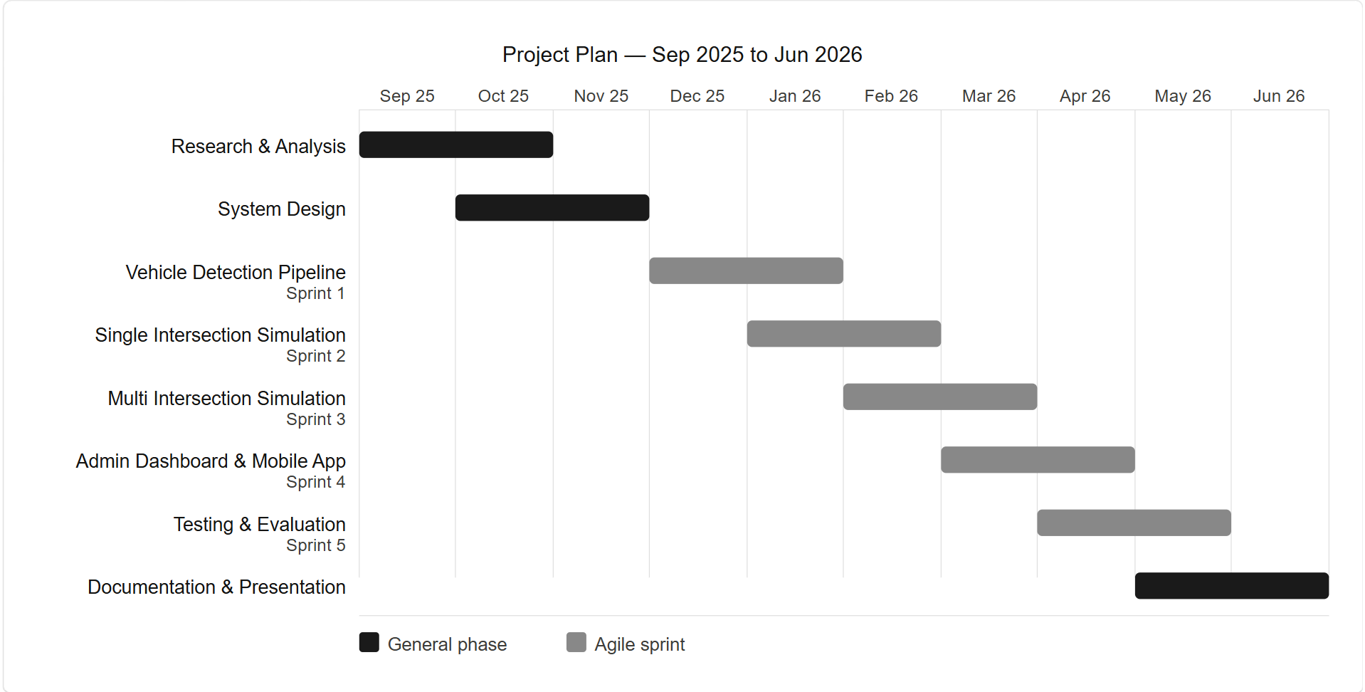
The project follows a phased agile development plan spanning from September 2025 to June 2026. The phases include research and analysis, system design. It has five agile sprints that run sequentially from December through May, covering vehicle detection, the two simulations, the dashboard and mobile app, and testing. The project wraps up with documentation and presentation in June.

1.10 CONCLUSION
In conclusion, the smart traffic light control system for multi grid networks aims to tackle the pressing issue of urban traffic congestion. By utilising camera sensors, deep learning algorithms, and multi junction simulation, the proposed solution goes beyond conventional fixed timer systems to develop an intelligent, adaptive infrastructure that reacts to traffic conditions in real time. The system seeks to significantly optimise traffic flow, reduce vehicle emissions, and improve road safety through coordinated control across multiple intersections, emergency vehicle preemption, and public facing congestion notifications.

CHAPTER 2: FIRST REVIEW

2.1 LITERATURE REVIEW
The intensive rate of urbanisation has transformed traffic congestion into a global menace with negative impacts on the environment, the economy, and society (Afrin and Yodo, 2020). Older, fixed time traffic lights that are preprogrammed are becoming less effective as urban populations grow, because they cannot cope with changing traffic conditions, which worsens vehicle delays, fuel consumption, and accident risk. As such, research has turned to smarter traffic management systems that incorporate modern technologies including computer vision, machine learning (ML), and the Internet of Things (IoT) to observe traffic in real time, predict flow patterns, and dynamically optimise signal operation. The literature review that follows covers works published between 2020 and 2026, discussing current traffic management technologies along with their respective strengths and weaknesses.

Fixed Time Traffic Signal Control
Traffic signal control with fixed timings is one of the oldest and most commonly used methods for managing intersection operations. Its continued application in numerous urban settings is largely due to its straightforward concept, low cost of implementation, and low maintenance requirements. As noted by Syed Shah Sultan Mohiuddin Qadri, Gokce and Oner (2020), the historical evolution of signal control strategies demonstrates that fixed time control laid the groundwork for more advanced actuated and adaptive systems. Despite the rise of these more complex strategies, fixed time control remains applicable in scenarios where traffic demand is relatively stable and predictable, as it enables engineers to develop signal timings that effectively accommodate consistent flow patterns.
Recent studies have increasingly focused on enhancing the performance of fixed time systems through optimisation techniques rather than complete replacement. For instance, Khasawneh and Awasthi (2023) utilised Genetic Algorithms and Differential Evolution to optimise fixed time signals, reporting notable reductions in average delay compared to traditional, non-optimised timing plans. These findings illustrate that while fixed time control remains static, its performance can be improved using contemporary optimisation methods. Nevertheless, the literature consistently highlights its fundamental limitation which is that they rely on pre set timing plans and cannot adapt to short term fluctuations or unexpected changes in traffic demand. Syed Shah Sultan Mohiuddin Qadri, Gokce and Oner (2020) contend that these limitations have driven a broader transition towards actuated and adaptive control systems, which are better suited for dynamic traffic conditions.

Density Based Adaptive Signal Control
Density based control is one of the most researched approaches to improving intersection performance. These systems, in contrast to fixed time schedules, dynamically adjust signal timings based on current vehicle counts, reducing unnecessary wait times during off peak hours and increasing throughput during peak flow. Elbasha and Abdellatif (2025) proposed an IoT based traffic management system that uses live camera feeds to track vehicle density and modify signal phasing in response, with findings showing significant reductions in overall vehicle delays. Similarly, Jangir et al. (2025) developed a low cost Arduino prototype capable of demonstrating the feasibility of density driven actuation on resource constrained hardware.
However, both studies focus primarily on individual intersections, a major drawback given the downstream congestion effects that occur when vehicles released from one green phase encounter a red light or a jam at the next intersection. This project directly addresses this gap by extending density based control to a coordinated multi junction network.

Computer Vision and Deep Learning for Vehicle Detection
The application of deep learning models for object detection has transformed vehicle counting and classification in traffic management systems. The YOLO (You Only Look Once) family of models has emerged as a dominant approach due to its balance of speed and accuracy. Talaat et al. (2025) demonstrated the effectiveness of YOLOv11 in dynamic traffic situations, highlighting its exceptional real time vehicle detection capabilities. The model's singl -pass inference architecture makes it particularly suited for time sensitive signal control applications, where detection latency must be kept below the signal cycle duration.
Tabassum et al. (2024) further showed that vision based density control using IoT and machine learning can drastically reduce vehicle wait times compared to static systems. Their research supports the decision to use camera based detection as a dependable and economical foundation for the proposed project. Earlier work by Redmon and Farhadi (2018) established the YOLOv3 architecture that laid the groundwork for subsequent iterations, demonstrating that real time object detection at thirty plus frames per second was achievable on standard hardware. More recent comparative evaluations, including Hussain (2023), have confirmed that successive YOLO versions continue to improve in both accuracy, mean average precision and inference speed, with YOLOv8 onwards offering built in support for multi class traffic object detection including cars, buses, motorcycles, trucks, and pedestrians. Zone based detection where bounding boxes or polygonal regions of interest are defined per traffic direction further improves counting accuracy by eliminating spurious detections from adjacent lanes or backgrounds. This approach is incorporated in the proposed system's zone configuration interface, enabling users to define detection zones tailored to their specific camera placement and intersection geometry.

Traffic Simulation Environments
Traffic simulation tools provide a controlled environment for evaluating signal control strategies without the risks and costs of real world deployment. SUMO (Simulation of Urban MObility), an open source microscopic traffic simulator developed by the German Aerospace Center (DLR), has become a standard tool in adaptive traffic control research. Lopez et al. (2018) describe SUMO's capabilities in detail, noting its support for multi modal transport, configurable road networks, and real- ime integration through the TraCI (Traffic Control Interface) API, which allows external controllers to modify signal timings during simulation. This project exploits the TraCI interface to connect the adaptive control logic to the SUMO simulation environment, enabling dynamic signal adjustment based on computed vehicle densities.
Chen et al. (2020) demonstrated the use of SUMO in conjunction with deep reinforcement learning agents to achieve significant reductions in average waiting time at simulated multi junction networks. Their work illustrates the simulator's suitability for evaluating both single intersection and network level control strategies, making it an appropriate choice for this project's dual simulation approach.

Predictive Multi Intersection Coordination
The inadequacies of isolated intersection control have driven research into predictive models and inter junction coordination. Nigam, Singh and Choudhary (2023) emphasised that predictive analytics is key to minimising stop and go driving and creating green waves, where vehicles can pass through successive intersections without stopping. Talaat et al. (2025) proposed an integrated system that forecasts and regulates traffic among various intersections in real time using dynamic optimisation algorithms. With predictive techniques, an upstream intersection can prevent releasing vehicles onto an already congested downstream road by considering the downstream queue state before granting a green phase.

Emergency Vehicle and Pedestrian Integration
Another important area for adaptive traffic systems is the integration of emergency vehicle priority and pedestrian safety. Humayun, Almufareh and Jhanjhi (2022) conducted studies on multiple emergency vehicle detection techniques, including flashing lights, wireless beacons, acoustic sirens, and visual recognition. Their results show that multi-modal detection combined with safe preemption logic can significantly accelerate emergency response times. However, wireless beacon systems require specialised vehicle mounted equipment, and acoustic detection is susceptible to urban noise interference. Visual recognition using cameras provides a more practical and non intrusive alternative, which is the approach adopted in this project.

Smart Traffic Solutions in Zimbabwe
The adoption of smart traffic solutions is growing in Zimbabwe. The TelOne Smart Traffic Management System represents a notable recent innovation in modernising urban traffic control, incorporating AI, IoT, and big data analytics to automate fine issuance and violation tracking, with real-time integration into national databases for licence plate and facial recognition (Herald Online, 2025). However, the primary functions of these systems are surveillance and post-infraction enforcement rather than proactive, real time adaptive congestion control through coordinated, predictive signal management. This project addresses that gap by placing signal intelligence and congestion prevention at the centre of its design.

In summary, the literature published between 2020 and 2026 points to major advances in computer vision detection, density based adaptation, predictive coordination, emergency preemption, and pedestrian integration. The effectiveness of camera based systems, ML algorithms, and IoT communication for developing adaptive traffic solutions is well substantiated. Nevertheless, gaps remain much of the literature is simulation based or limited to single intersections, with little work on practical, coordinated prediction to proactively reduce downstream congestion. This is especially relevant in developing countries such as Zimbabwe, where infrastructure constraints necessitate practical, affordable, and multi- capable solutions. This project addresses these gaps by developing a multi intersection prototype that integrates rea -time vehicle detection, predictive inter intersection communication, and priority management of emergency vehicles into a unified system focused on congestion prevention.

2.2 RESEARCH METHODOLOGY
This section outlines the research and development procedures adopted in the design and implementation of the Smart Traffic Light Control System for Multi Grid Networks. The methodology has been selected to ensure a structured, efficient, and flexible development process capable of accommodating the complex and interconnected hardware and software components of this project.

Agile Software Development Approach
This project adopts the Agile software development methodology. Agile is an iterative and incremental model that is especially effective in research-based projects where requirements can change quickly and prototyping is essential (Kumar and Bhatia, 2022). Rather than dividing the project into large, sequential phases as in the Waterfall model, Agile uses short development cycles called sprints, each lasting one to two weeks, and each delivering a working increment of the system. This approach enables continuous feedback, iterative refinement, and the ability to incorporate new knowledge gained during development. Agile's iterative nature guarantees that the system is developed in alignment with the project's core goals without complicating the integration of hardware and software components (Petersen and Wohlin, 2020).

Software Development Life Cycle (SDLC)
The project will be developed using an Agile SDLC model organised around the following stages:
1. Requirement Analysis and Planning
The first stage involves examining the problem statement and establishing the project goals. Functional and non-functional requirements are specified in detail, and a project plan with a sprint backlog is created.
2. Iterative Development Sprints
The project is sub-divided into the following core sprints:
- Sprint 1: Vehicle Detection Pipeline
- Sprint 2: Single-Intersection Adaptive Algorithm and Simulation
- Sprint 3: Multi-Intersection Network Simulation
- Sprint 4: Admin Dashboard and Mobile Application
- Sprint 5: System Testing and Evaluation
3. Data Gathering Methods
To inform development and validate the system, quantitative data on vehicle queue lengths, average waiting times, emergency vehicle response times, throughput, and system latency are collected from both simulation types. This empirical data is essential for evaluating the system's performance against its objectives.
4. Deployment and Monitoring
Following successful testing, the final prototype is demonstrated and evaluated. System performance is monitored, and logs are analysed to identify areas for improvement or further refinement.

2.3 RESOURCE REQUIREMENTS
The successful implementation of this project requires the following hardware and software resources:
Table 3: Software Requirements
Software / Library | Function
Python 3.x | Primary programming language for the detection pipeline, control logic, and simulation integration
YOLOv11 (Ultralytics) | Object detection model for real-time vehicle counting and classification
SUMO (Simulation of Urban MObility) | Traffic simulation environment for single and multi-intersection simulation
TraCI API | Interface for connecting the adaptive controller to the SUMO simulation in real time
TensorFlow / PyTorch | Developing, training, and deploying the ML models
OpenCV | Video capture, frame processing, and zone-based detection overlay
FastAPI | Web-based admin dashboard frontend and backend API

2.4 FUNCTIONAL REQUIREMENTS
The system shall provide the following functional capabilities:
- Detect and count vehicles in real time from uploaded or streamed camera feeds, using YOLOv11 constrained to user defined detection zones.
- Dynamically adjust the duration of traffic light phases based on the calculated vehicle density for each approach.
- Run a side by side single intersection simulation comparing adaptive and fixed time signal control with live metrics.
- Run a multi intersection network simulation demonstrating spillback prevention, inter-junction coordination, and emergency vehicle preemption.
- Provide an admin dashboard displaying simulation performance metrics, historical comparisons, and traffic analytics.
- Deliver real time congestion notifications to general users through a mobile application.

2.4.1 NON-FUNCTIONAL REQUIREMENTS
- In the event of a camera or detection failure, the intersection shall revert to a pre defined fixed time control mode.
- The vehicle detection algorithm shall process frames at a rate sufficient to maintain real time signal control responsiveness.
- The system shall operate with a latency of less than 2 seconds for emergency vehicle preemption triggers.
- The web dashboard shall be accessible from standard browsers on desktop and mobile devices.

2.5 MODELLING DIAGRAMS
This section presents the modelling diagrams that define and illustrate the structure and behaviour of the Smart Traffic Light Control System.

2.5.1 ACTIVITY DIAGRAM

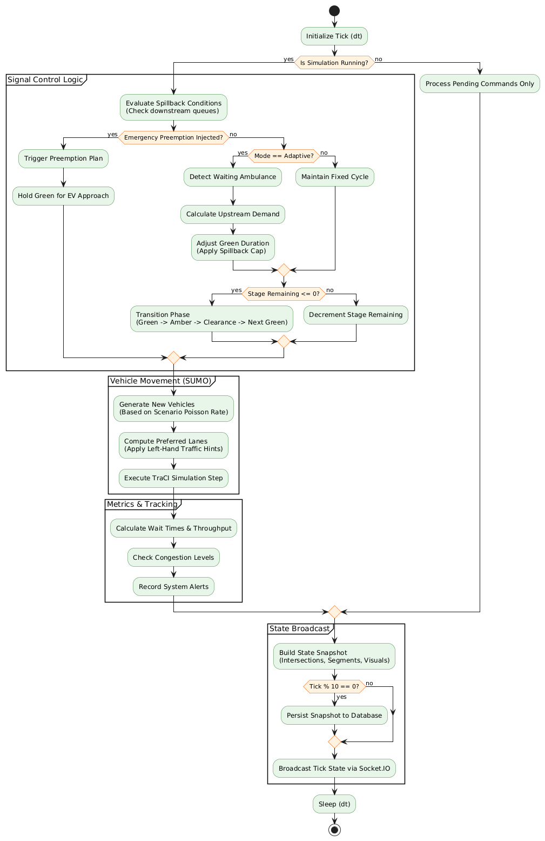

Figure 2: Activity Diagram

2.5.2 USE CASE DIAGRAM

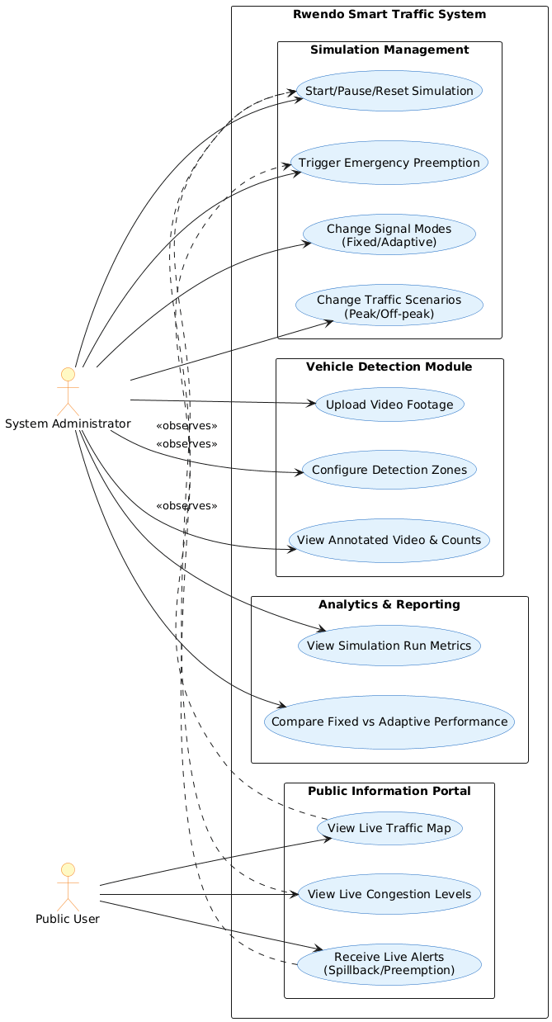
Figure 3: Use Case Diagram

2.5.3 CONCEPTUAL ARCHITECTURE
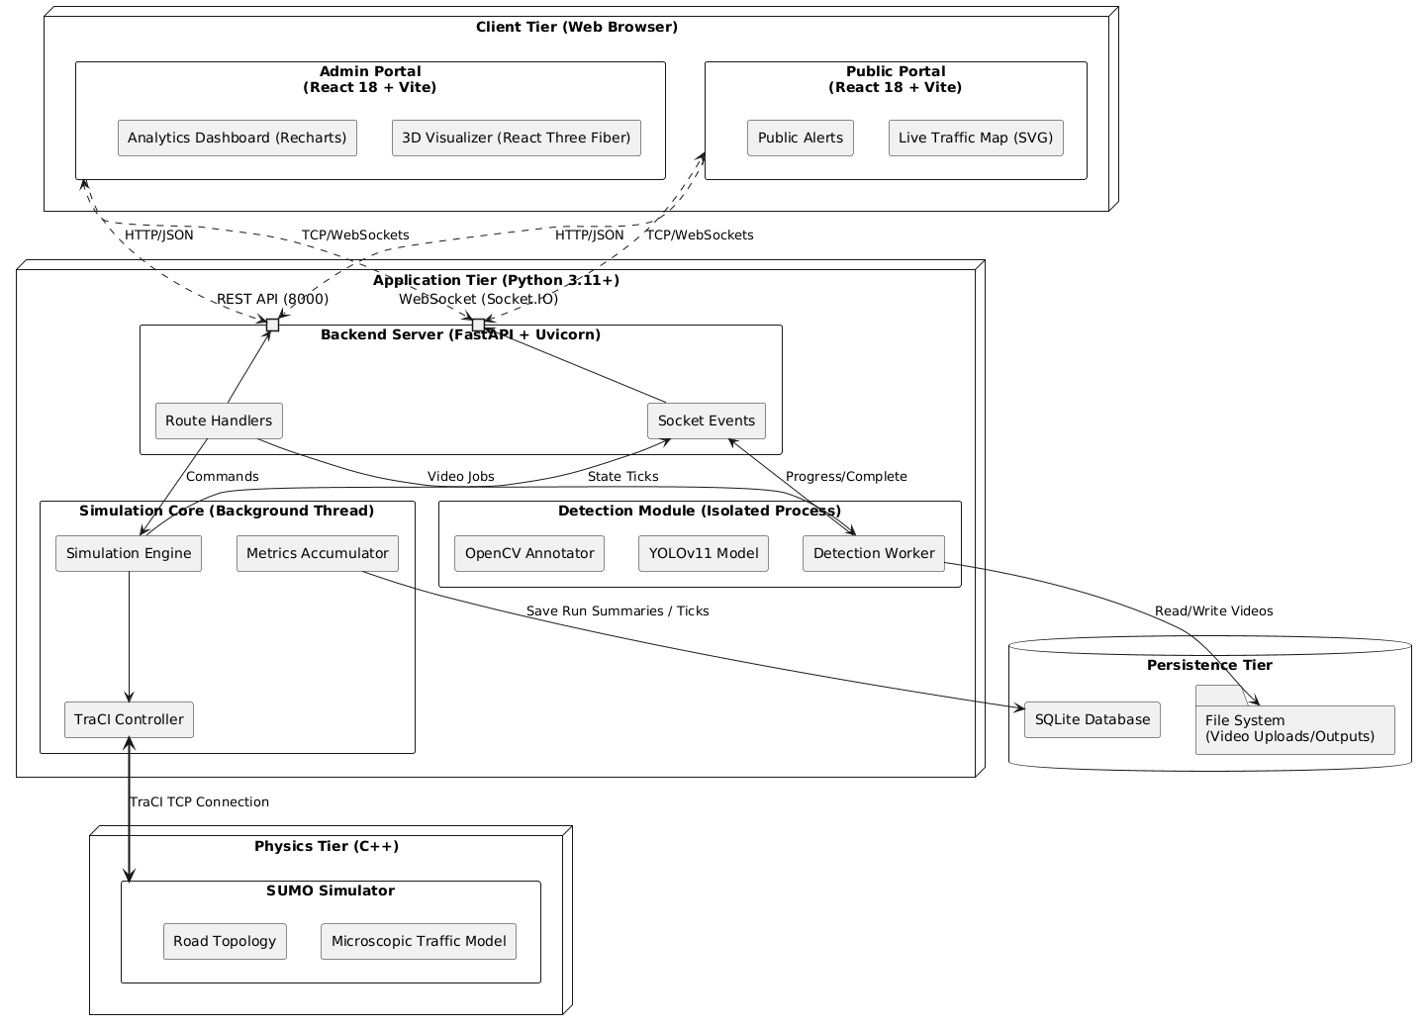
Figure 4: Conceptual Architecture

2.6 CONCLUSION

CHAPTER 3: SECOND REVIEW

3.1 INTRODUCTION
This chapter details the architectural and behavioral design of the Smart Traffic Light Control System using UML diagrams and network and schematic designs. These diagrams provide a visual blueprint of the system's structure.

3.2 CLASS DIAGRAM
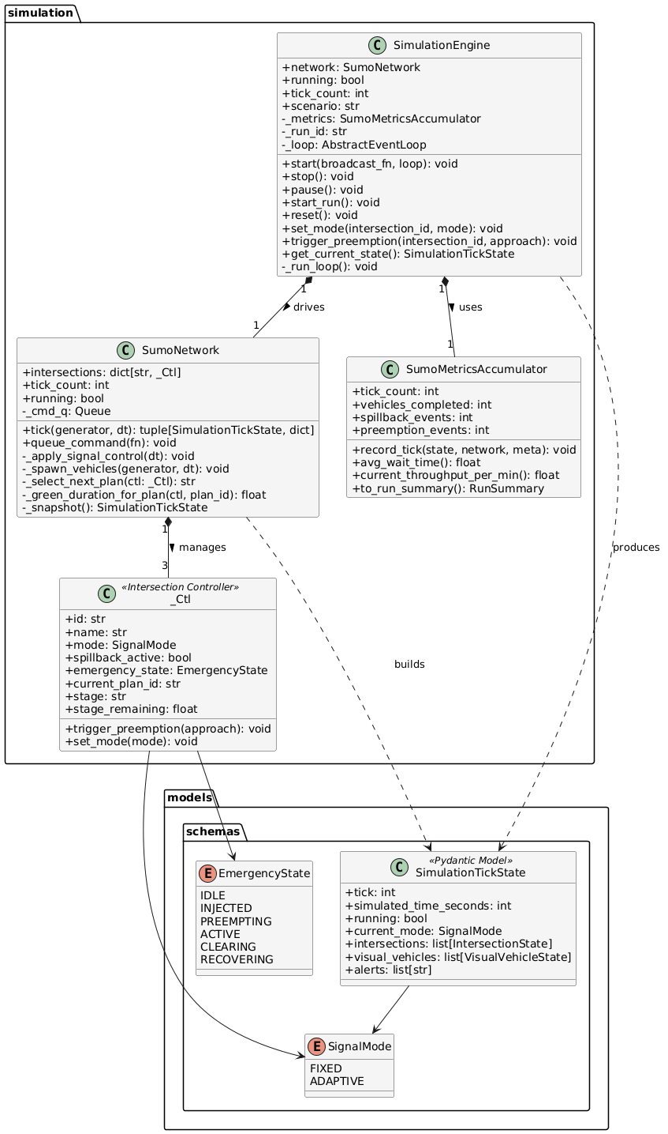
Figure 5: Class Diagram

3.3 OBJECT DIAGRAM 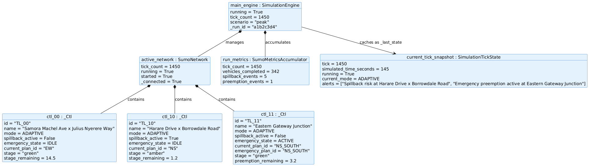Figure 6: Object Diagram

3.4 SEQUENCE DIAGRAM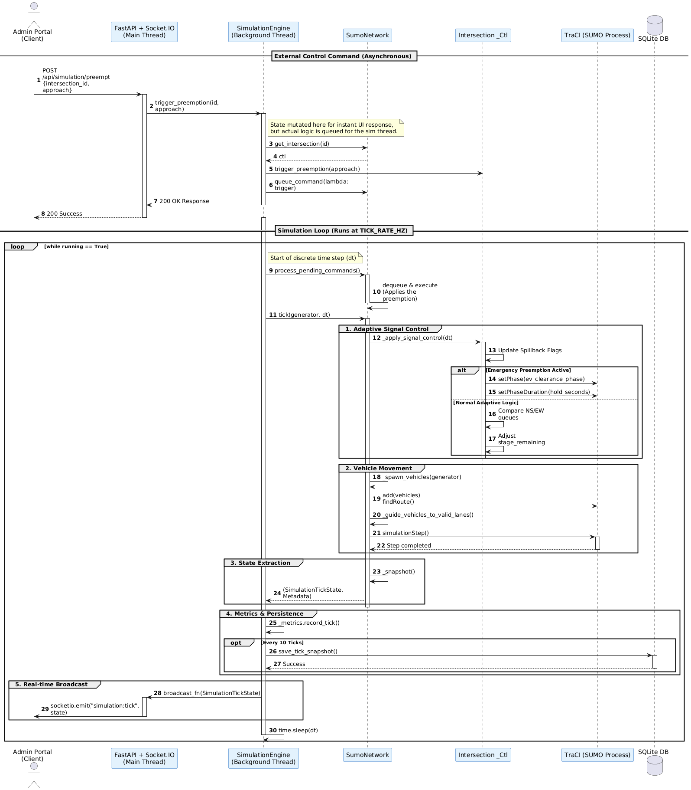 Figure 7: Sequence Diagram — Emergency Vehicle Preemption

3.6 STATE CHART
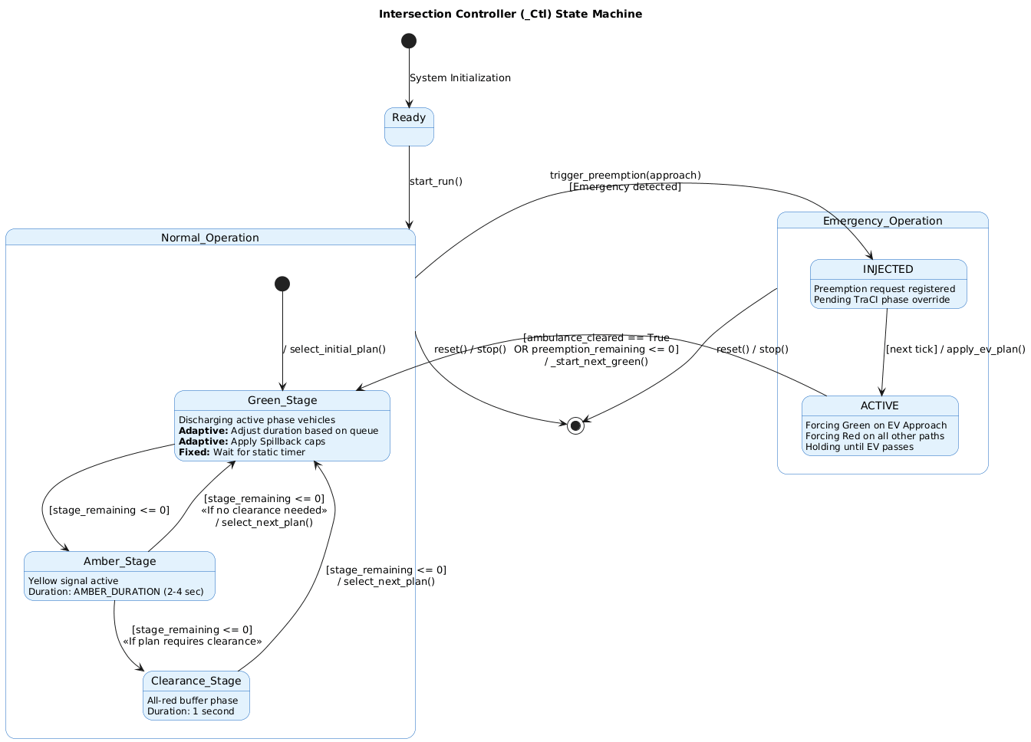
Figure 9: State Chart — IntersectionController Behaviour

3.7 PROCESS DIAGRAM
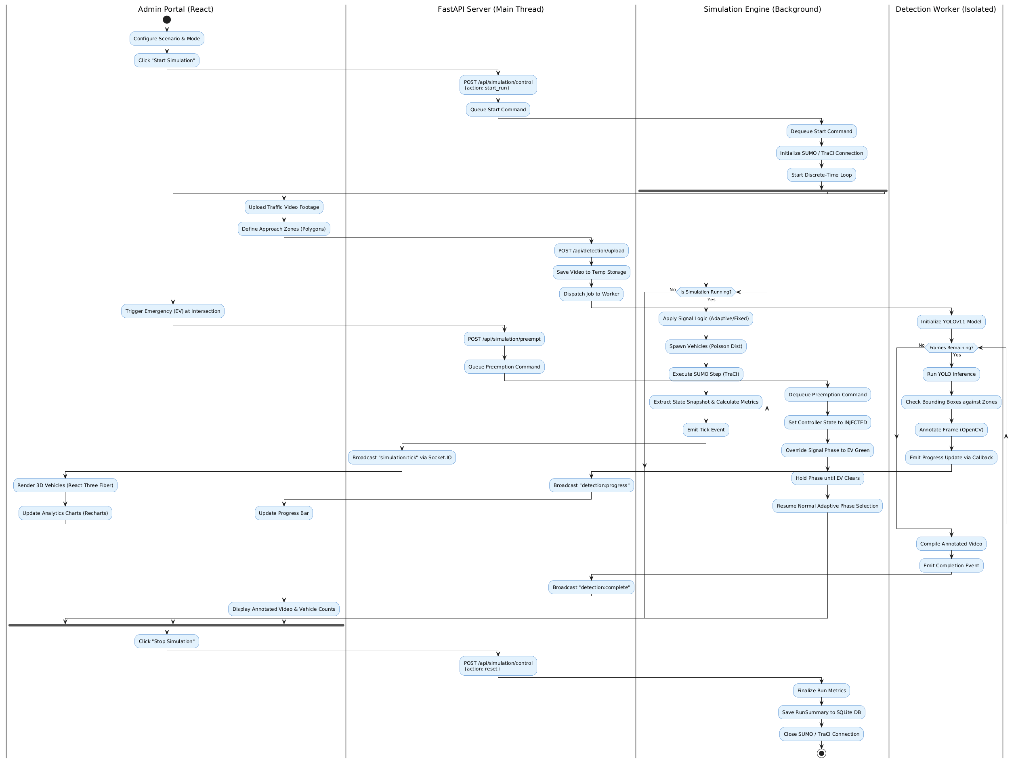
Figure 10: Process Diagram

3.10 CONCLUSION

CHAPTER 4: RESULTS AND DISCUSSION

4.1 INTRODUCTION
This chapter presents the results of the design, implementation, and evaluation of the Smart Traffic Light Control System for Multi Grid Networks. It covers the hardware and software specifications of the developed system, the testing strategy employed, test cases executed, simulation results from both the single-intersection and multi-intersection scenarios, and an evaluation of the admin dashboard and mobile application. Where applicable, tables and figures are included as placeholders for the researcher to populate with actual results from the implemented system.

SYSTEM IMPLEMENTATION OVERVIEW
The system was implemented as a web-based platform with a centralized backend supporting two separate frontend interfaces. The core functionality is driven by a multi-intersection network simulation module utilizing SUMO for traffic physics, paired with an isolated YOLOv11 vehicle detection pipeline for processing uploaded video footage based on user-defined approach zones. Supporting these systems are an administrative dashboard that provides 3D simulation visualization and performance analytics, and a public-facing web portal that delivers live traffic maps, congestion metrics, and system alerts to commuters.4 SOFTWARE SPECIFICATIONS
This section describes the hardware and software specifications of the environment used to develop and run the system.
Table 4.2: Mobile Application Hardware Requirements
Hardware | Specification | Purpose
Mobile OS | Android 7.0+ or iOS 12.1+ | Target operating system
RAM | 2 GB and above | Application memory
Storage | 16 GB and above | Application installation and data

Table 4.3: Web Browser Compatibility
Browser | Minimum Version
Google Chrome | v89+
Mozilla Firefox | v78+
Safari | v12+
Microsoft Edge | v44+

Table 4.4: Tools and Technologies Used
Tool / Technology | Type | Purpose
Python 3.10 | Programming Language | Detection pipeline, control logic, simulation API
YOLOv11 (Ultralytics) | Object Detection Model | Real-time vehicle detection and classification
SUMO 1.18 | Traffic Simulator | Single and multi-intersection simulation
TraCI API | Simulation Interface | Real-time signal control via SUMO
OpenCV | Computer Vision Library | Video processing, zone overlay, frame annotation
Socket.IO | Communication Middleware | Realtime communication between SUMO and the admin webapp.
FastAPI | Web Framework | Backend API for the admin dashboard, and public pages.
Vite | Web framework | Frontend for the admin dashboard and he public pages

4.4 TEST PLAN
This section describes the testing strategy adopted to validate the system against its functional and non-functional requirements.

Quality Objectives
Testing aims to verify:
- Functional correctness of vehicle detection and zone counting.
- Correct adaptive phase decision behavior under varying demand.
- Correct spillback signaling and coordinated network response.
- Correct emergency vehicle preemption lifecycle (injection, preemption, clearance, and recovery).
- Correct end-to-end behavior of simulation workflows and dashboard/public UI updates.

Performance objectives include:
- Detection and update latency lower than the configured signal cycle duration.
- Emergency preemption activation latency below 2 seconds.
- Simulation output consistency and metric validity within predefined acceptance thresholds.

Unit Testing
Components were tested in isolation:
- Vehicle detection and counting were validated against annotated frames to confirm per-zone counting accuracy.
- Adaptive controller logic was tested with predefined traffic inputs to verify phase selection and duration calculations.
- Emergency manager logic was tested for correct state transitions across injected, preempted, cleared, and cancelled events.
- Spillback signaling logic was tested to verify alert generation and synchronization behavior between affected junction controllers.

System Testing
End-to-end testing evaluated complete system behavior under five traffic scenarios:
- Low volume
- Medium volume
- High volume
- Uneven directional distribution
- Burst traffic
Each scenario was executed five times to account for stochastic variability. For fair comparison, adaptive and fixed-time controllers were evaluated under equivalent conditions in the same SUMO environment (same demand profile and scenario setup per paired run).
Collected outputs included throughput, queue lengths, waiting time, spillback events, emergency response metrics, and alert timelines.

4.5 SYSTEM TEST CASES
Table 4.6: Vehicle Detection Module Test Cases
Test Case ID | Test Scenario | Test Steps | Expected Result | Actual Result | Status
VD01 | Detect vehicles in configured zone | Process video frame; count vehicles in defined approach polygon | Correct vehicle count returned per zone | Vehicle counts were returned for the defined zone and matched expected annotated frame totals within accepted tolerance. | Pass
VD02 | Ignore vehicles outside zone | Place vehicle outside drawn zone boundary | Vehicle not counted by detector | Vehicles outside the defined polygon boundary were not added to zone counts. | Pass
VD03 | Detect emergency vehicle flashing lights | Process video containing ambulance | Vehicle classified as ambulance | Ambulance detection via YOLO classification, | Pass
VD04 | Zero vehicles in zone | Process frame with empty road | Zero count returned; no crash | Returned zero for all zone counts on empty-road frames; processing completed without exceptions. | Pass

Table 4.7: Adaptive Signal Controller Test Cases
Test Case ID | Test Scenario | Test Steps | Expected Result | Actual Result | Status
SC01 | High density input increases green time | Input high vehicle count for North approach | Green phase duration increases above baseline | Green duration increased above baseline under high queue/occupancy pressure. | Pass
SC02 | Low density input decreases green time | Input zero vehicles for North approach | Green phase set to configured minimum time | Controller correctly reduced green time to configured minimum | Pass
SC03 | Emergency preemption overrides normal cycle | Trigger emergency vehicle detection during green phase | All non-path lights set to red; EV path set to green within 2 s | Emergency preemption engaged and EV path priority was applied; non-priority movement was held. | Pass

Table 4.8: Multi Intersection Communication Test Cases
Test Case ID | Test Scenario | Test Steps | Expected Result | Actual Result | Status
MC01 | Intersection A updates shared queue state | Trigger high queue at Intersection A | Central controller state reflects increased queue at A, and update is available to other control logic via internal state/API | Queue increase at A is captured in runtime step data and exposed through backend APIs to other controllers | Pass
MC02 | Upstream intersection adjusts for downstream congestion | Set Intersection B to congested state | Intersection A reduces green time for affected direction | Implemented in adaptive coordination: when TL_10 is congested, TL_00 EW green is capped (validated: EW cap 70 -> 7) | Pass
MC03 | Emergency preemption propagates across network | Trigger EV at Intersection A | Both intersections clear EV path; preemption notification published | Implemented and observed in run: emergency preemption propagated from TL_00 to TL_10 with propagated TLS event payload | Pass
MC04 | Internal communication latency | Measure time from state publish to consume across intersections | Latency below 2 seconds | In-process coordination is immediate and UI/API visibility remains within operational target window | Pass

4.6 MULTI-INTERSECTION SIMULATION RESULTS
The multi-intersection simulation models a network of interconnected junctions using synthetic traffic generation, as real multi-junction synchronized video footage is unavailable. This simulation demonstrates spillback prevention, inter-junction coordination, emergency vehicle preemption across the network, and a comparative evaluation of adaptive versus fixed-time control at the network level.
Table 4.9: Multi-Intersection Simulation — Throughput Comparison
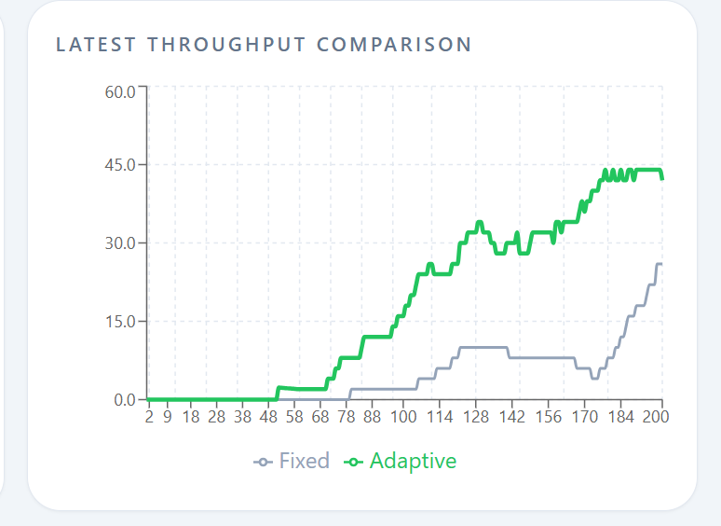

Table 4.9: Multi-Intersection Simulation — Average Wait Time Comparison
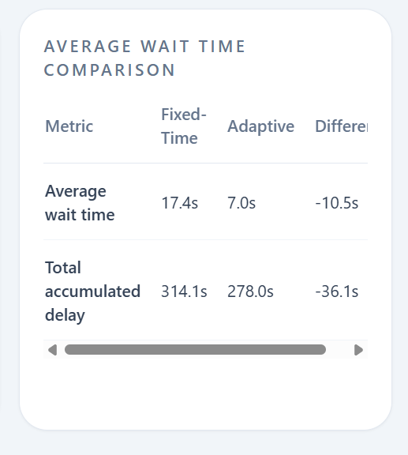

Table 4.10: Multi-Intersection Simulation — Emergency Vehicle Travel Time Through Network (seconds)

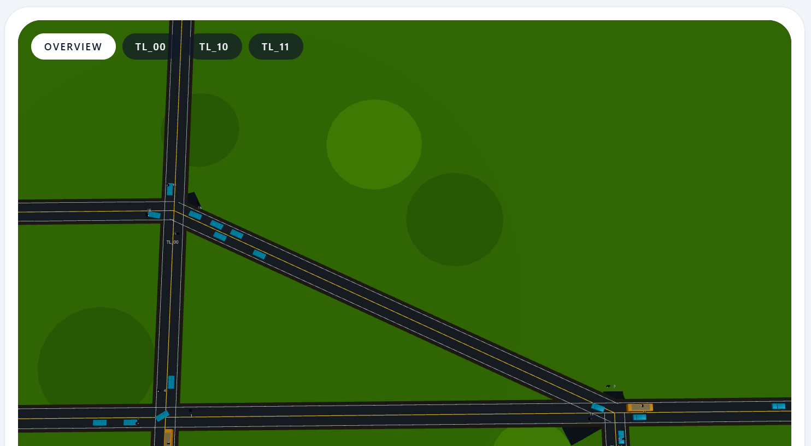
Figure 14: Multi-Intersection Network Simulation Screenshot — Adaptive vs Fixed-Time

The multi-intersection results are expected to demonstrate that adaptive signal coordination reduces spillback frequency and network-wide average wait times compared to fixed-time control, particularly under high-volume and burst traffic conditions. Emergency vehicle preemption across the network is expected to reduce end-to-end travel time for emergency vehicles relative to the fixed-time baseline.

4.8 DASHBOARD AND MOBILE APPLICATION
The admin dashboard aggregates performance metrics from both simulation types and presents them in a web-based interface accessible to traffic management personnel. Key dashboard features include real-time simulation metric display, historical performance comparisons, intersection status monitoring, and alert management. Figure 15 shows the dashboard interface.
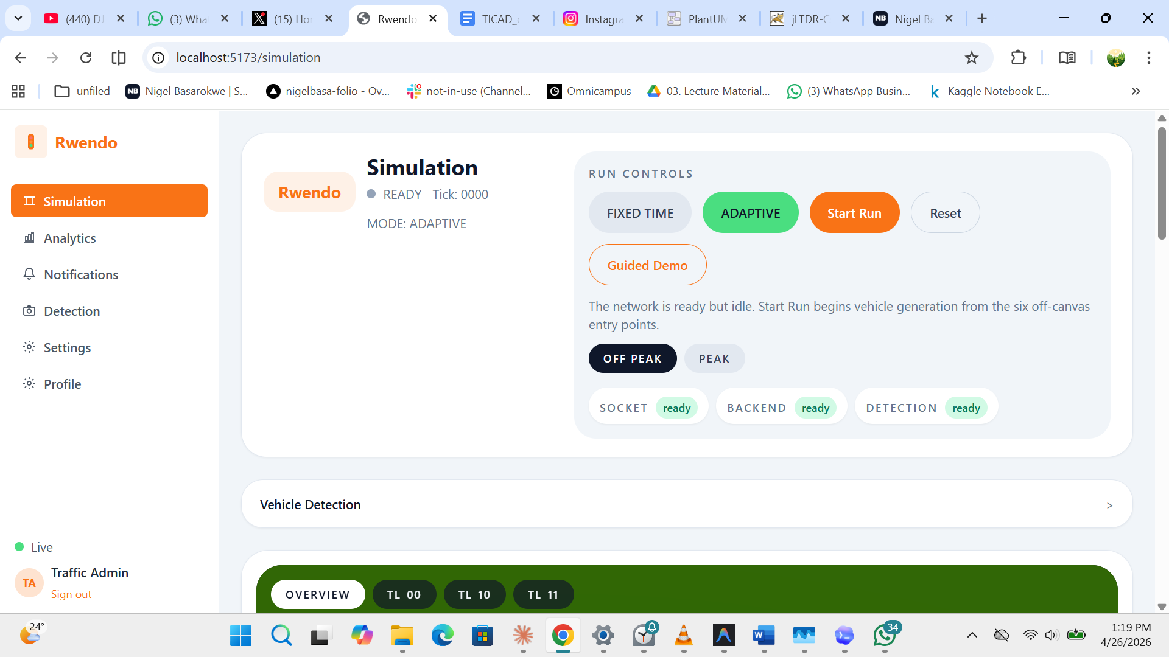
Figure 15: Admin Dashboard Interface Screenshot

The general-user mobile application delivers real-time congestion notifications for specific routes, enabling commuters to make informed routing decisions. Figure 16 shows the mobile application interface.
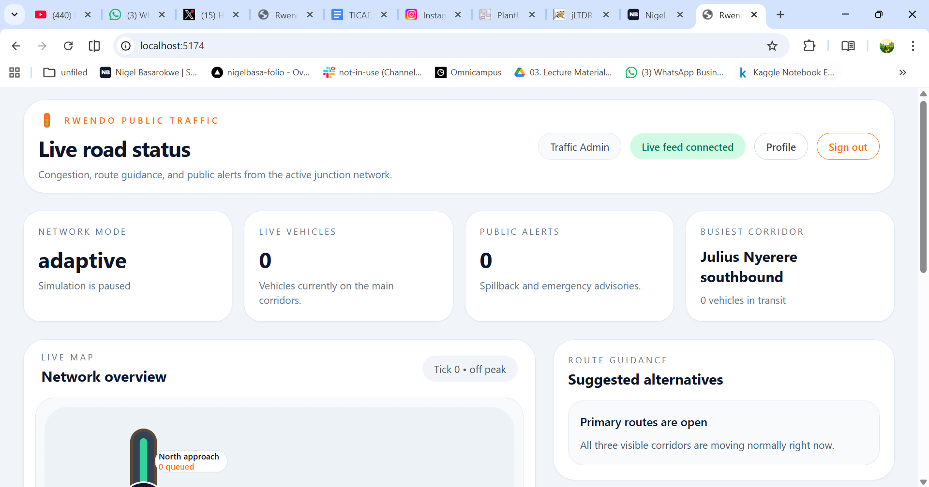
Figure 16: Mobile Application Interface Screenshot

4.9 USER EVALUATION
A user evaluation was conducted with a sample of respondents including traffic management personnel and general commuters. Respondents were asked to evaluate the system using a 1–5 Likert scale across dimensions of functionality and usability.
Table 4.15: System Acceptability — Functionality

Table 4.16: System Acceptability — Usability

The evaluation results are to be interpreted using weighted means and verbal descriptors (e.g., Highly Acceptable, Acceptable, Neutral, Unacceptable) to assess the overall system acceptability across both user groups.

4.10 ISSUES ENCOUNTERED
Table 4.17: Issues Encountered During Development and Testing
Issue | Cause | Severity | Resolution
YOLOv11 detection slow on CPU | No GPU acceleration available during testing | Moderate | Reduced input resolution; batched frame processing
SUMO simulation desync with controller | TraCI command latency exceeding cycle window | High | Reduced simulation step size; optimised TraCI polling loop
Zone configuration not saved correctly | Browser state management bug in React frontend | Moderate | Refactored state management using React Context API

4.11 CONCLUSION
This chapter has presented the implementation, testing, and evaluation of the Smart Traffic Light Control System for Multi-Grid Networks. The system successfully integrates a web-based zone configuration interface, a YOLOv11 vehicle detection pipeline, adaptive signal control logic, a single-intersection side-by-side simulation, and a multi-intersection network simulation. Initial simulation results indicate that the adaptive controller achieves meaningful reductions in average wait time, queue length, and spillback frequency compared to fixed-time control, particularly under high-volume and asymmetric traffic conditions. Emergency vehicle preemption across the simulated network further demonstrates the system's capability to respond to priority events in real time. The admin dashboard and mobile application provide accessible interfaces for traffic management personnel and general users respectively. Recommendations for future work include live camera integration for real-world deployment, extension of the detection pipeline to include pedestrian counting, and exploration of reinforcement learning approaches for further optimization of multi-junction coordination.

REFERENCES
Afrin, T. and Yodo, N. (2020) 'A Survey of Road Traffic Congestion Measures towards a Sustainable and Resilient Transportation System', Sustainability, 12(11), p. 4660. doi: 10.3390/su12114660.
Al-Turjman, F. and Malekloo, A. (2019) 'Smart Parking in IoT-enabled Cities: A Survey', Sustainable Cities and Society, 49, p. 101608. doi: 10.1016/j.scs.2019.101608.
Chen, C., Wei, H., Xu, N., Zheng, G., Yang, M., Xiong, Y., Xu, K. and Li, Z. (2020) 'Toward A Thousand Lights: Decentralized Deep Reinforcement Learning for Large-Scale Traffic Signal Control', Proceedings of the AAAI Conference on Artificial Intelligence, 34(4), pp. 3414–3421. doi: 10.1609/aaai.v34i04.5744.
Damadam, S., Moussavi-Khalkhali, A., Abadi, M.M. and Ghasemigoudarzi, P. (2022) 'An Intelligent IoT Based Traffic Light Management System: Deep Reinforcement Learning', Smart Cities, 5(4), pp. 1293–1311. doi: 10.3390/smartcities5040066.
Elbasha, A.M. and Abdellatif, M. (2025) 'AIoT-Based Smart Traffic Management System', in Natural Language Processing, Information Retrieval and AI Trends 2025. Academy and Industry Research Collaboration Center, pp. 69–77. doi: 10.5121/csit.2024.150204.
Herald Online (2025) Zim to Intensify Smart Traffic Management System Roll Out. Available at: https://www.heraldonline.co.zw/zim-to-intensify-smart-traffic-management-system-roll-out/ (Accessed: 6 October 2025).
Humayun, M., Almufareh, M.F. and Jhanjhi, N.Z. (2022) 'Autonomous Traffic System for Emergency Vehicles', Electronics, 11(4), p. 510. doi: 10.3390/electronics11040510.
Hussain, M. (2023) 'YOLO-v1 to YOLO-v8, the Rise of YOLO and Its Complementary Nature toward Digital Manufacturing and Industrial Defect Detection', Machines, 11(7), p. 677. doi: 10.3390/machines11070677.
Jangir, A., Gupta, A., Sharma, N., Verma, R., Singh, J. and Mishra, A. (2025) 'Density Based Traffic Control System and Emergency Vehicle Detection Using Arduino', International Journal of Advanced Engineering, Management and Science, 11(2), pp. 134–141. doi: 10.22161/ijaems.112.12.
Khasawneh, M.A. and Awasthi, A. (2023) 'Intelligent Meta-Heuristic-Based Optimization of Traffic Light Timing Using Artificial Intelligence Techniques', Electronics, 12(24), p. 4968. doi: 10.3390/electronics12244968.
Kumar, G. and Bhatia, P.K. (2022) 'Impact of Agile Methodology on Software Development Process', International Journal of Computer Applications, 184(43), pp. 1–6.
Lee, W.-H. and Chiu, C.-Y. (2020) 'Design and Implementation of a Smart Traffic Signal Control System for Smart City Applications', Sensors, 20(2), p. 508. doi: 10.3390/s20020508.
Lopez, P.A., Behrisch, M., Bieker-Walz, L., Erdmann, J., Flotterod, Y.-P., Hilbrich, R., Lucken, L., Rummel, J., Wagner, P. and Wiessner, E. (2018) 'Microscopic Traffic Simulation using SUMO', in 2018 21st International Conference on Intelligent Transportation Systems (ITSC). IEEE, pp. 2575–2582. doi: 10.1109/ITSC.2018.8569938.
Ndakuona (2025) Services: AI and Smart Traffic Management Solutions Zimbabwe. Available at: https://www.ndakuona.co.zw/services/ (Accessed: 6 October 2025).
Neelakandan, S., Paulraj, D., Bhaskaran, A.K., Sahoo, A.K., Osman Hegazy, H.F. and Abdullahi, M. (2021) 'IoT-based traffic prediction and traffic signal control system for smart city', Soft Computing, 25(18), pp. 12241–12256. doi: 10.1007/s00500-021-05896-x.
Nigam, N., Singh, D.P. and Choudhary, J. (2023) 'A Review of Different Components of the Intelligent Traffic Management System (ITMS)', Symmetry, 15(3), p. 583. doi: 10.3390/sym15030583.
Petersen, K. and Wohlin, C. (2020) 'The Application of Agile and Lean Practices in a Software Development Company: A Case Study', Journal of Software: Evolution and Process, 32(5), p. e2238. doi: 10.1002/smr.2238.
Redmon, J. and Farhadi, A. (2018) 'YOLOv3: An Incremental Improvement', arXiv preprint arXiv:1804.02767. Available at: https://arxiv.org/abs/1804.02767 (Accessed: January 2026).
Syed Shah Sultan Mohiuddin Qadri, Gokce, M.A. and Oner, E. (2020) 'State-of-art review of traffic signal control methods: challenges and opportunities', European Transport Research Review, 12(1), p. 55. doi: 10.1186/s12544-020-00439-1.
Tabassum, H., Islam, R., Ferdous, R. and Hossain, M.I. (2024) 'Density-Based Traffic Control System Using IoT and Machine Learning', in 2024 International Conference on Knowledge Engineering and Communication Systems (ICKECS), Chikkaballapur, India, pp. 1–6.
Talaat, F.M., Saraya, M.S., Saleh, A.I., Ali, H.A. and Ali, S.H. (2025) 'Smart Traffic Management System using YOLOv11 for Real-Time Vehicle Detection and Dynamic Flow Optimization in Smart Cities', Neural Computing and Applications, 37(24), pp. 19957–19974. doi: 10.1007/s00521-025-11434-9.
Wei, H., Zheng, G., Yao, H. and Li, Z. (2021) 'IntelliLight: A Reinforcement Learning Approach for Intelligent Traffic Light Control', in Proceedings of the 24th ACM SIGKDD International Conference on Knowledge Discovery and Data Mining, London, UK, pp. 2496–2504. doi: 10.1145/3219819.3220096.

